 Collaborate With Webex Softphone User Quick Reference Guide

June 2022

**Contents**

Collaborate With Webex Softphone User Guide 3

System Requirements and Support Policy 3

Changes to Supported Windows Operating Systems 3

System Requirements 3

Windows PCs Recommended Minimum System Requirements 3

Mac Recommended Minimum System Requirements 4

iPhone and iPad 4

Android Smartphones 4

Web 4

Chromebook 4

Signing Into the Webex App 5

First Time Login 6

Default Landing Screen 7

Personalisation/ Theme 7

The Webex App for Windows and Mac 8

Client Overview 8

Status, Profile and Preferences 8

Changing User Profile Picture 8

Changing User Status 9

Changing Availability Status 9

Navigation Menu 10

Contacts 10

Calling 10

Keypad 10

Help 10

Add Contact/Make Call 10

Search 12

Devices 12

Call Settings 13

Call Pickup 13

Voicemail 13

Personalising Your Webex Collaborate Service 14

Settings 14

Settings: General 15

Settings: Audio 15

Settings: Video 16

Settings: Notifications 16

Settings: Privacy 17

Settings: Appearance 17

Settings: Phone Service 18

Settings: Calling 18

Settings: Advanced Call Settings 19

Settings: Devices 20

# Collaborate With Webex Softphone User Guide

This document contains an overview of the core capabilities of the Webex Collaborate Softphone service. Users can access a full help guide from within the application by clicking on the help icon.

## System Requirements and Support Policy

Webex is supported on specific versions of Windows, Mac, iPhone, iPad, Android, and Web.

### Changes to Supported Windows Operating Systems

In the October 2021 (41.10) release, the minimum supported Windows operating system will change to Windows

10. We will no longer provide bug fixes or updates for earlier operating systems. To have the best experience possible, plan to upgrade your operating system.

In the January 2022 (42.1) release, Cisco Webex will officially end of life support for Windows operating systems earlier than Windows 10. At that time, you will no longer be able to sign in to the Webex app using any earlier operating systems.

### System Requirements

Review these system requirements to verify that you can use Webex on your computer, mobile device, or web browser.

Keep in mind that we don't support using Webex with pre-release or early release programs, such as the Apple Beta Software, Windows Insider Program, Google Android Beta, or any other similar programs.

The performance of the Webex app may also be influenced by other factors, for example: network connectivity or other applications on your devices.

### Windows PCs Recommended Minimum System Requirements

* Windows 7 Service Pack 1 and later. Make sure your drivers are up-to-date.
* Intel Dual-Core CPU 2.XX GHz or AMD processor (4 GB of RAM minimum recommended).

### Mac Recommended Minimum System Requirements

These requirements are continuously reviewed and may be revised.

* MacOS 10.12 and later on a supported Mac. .
* M1 chip or Intel CPU-based (4 GB of RAM minimum recommended).

### iPhone and iPad

* iOS 13.0 and later, and iPadOS 13.1 and later

### Android Smartphones

* Oreo 8.0 and later (2GB of RAM required).

### Web

* Last two major releases of one of these browsers: Google Chrome, Mozilla Firefox, Apple Safari, and Microsoft Edge on computers running Windows, Mac, or Linux.

You can only use the calling and meetings features from the Webex for Web app using Firefox, Chrome, and Safari.

### Chromebook

* The messaging, basic calling, and meetings features from Webex for Android are supported.

Webex is proactively tested against versions of supported platform operating systems (OS): Windows, Mac, iOS, and Android. Compatibility and support for new OS versions is being provided in the following manner:

Compatibility—We proactively monitor upcoming OS versions and validate Webex for compatibility with OS Beta releases. Our best effort is made to address any blocking issues or incompatibilities discovered during testing.

Example: iOS 14 is planned to be released in September 2020. The current version of Webex for iOS is validated for compatibility with iOS 14 Beta versions. If blocking issues are discovered, they're fixed and released in an updated version of Webex for iOS before the iOS 15 GA release date. If no blocking issues are discovered, the current Webex version is considered compatible with iOS 15.

Fixes are incorporated as per the Cisco support and maintenance policy.

## Signing Into the Webex App

After launching the application for the first time a user will see the following screen.

Select **Sign in**.

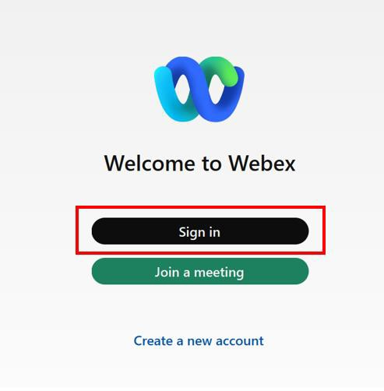

Enter allocated UserID and select **Next**.

**Note**: UserID is normally your email address.

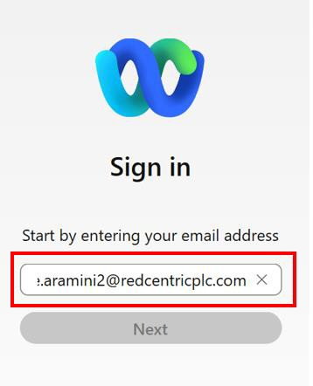

Enter Unity password and press Submit.

**Note**: Customers that which have “Single sign on” enabled would utilise their Window’s password.

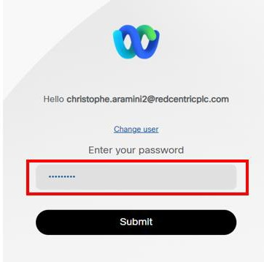

### First Time Login

**Note:** On **first login** a user will receive an emergency services splash screen. Once accepted by selecting **OK**, the notification will not be visible on subsequent logins.

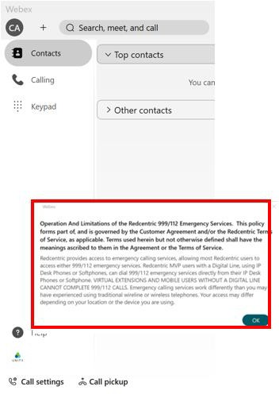

### Default Landing Screen

On login the Webex client will open on the **Contact view by default.**

***Note:*** *Users can change their landing screen preferences from the general settings menu item*

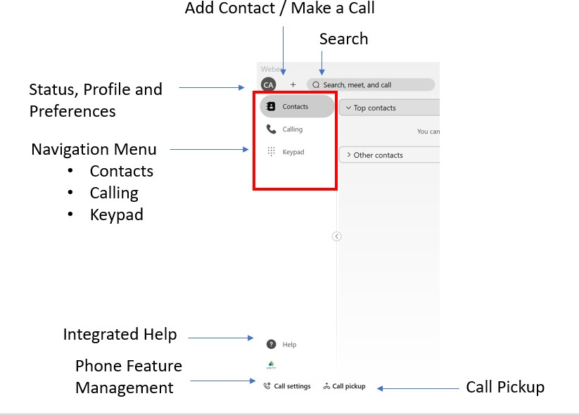

### Personalisation/ Theme

Users can update their own personal theme via - **Settings>Appearance>Theme**

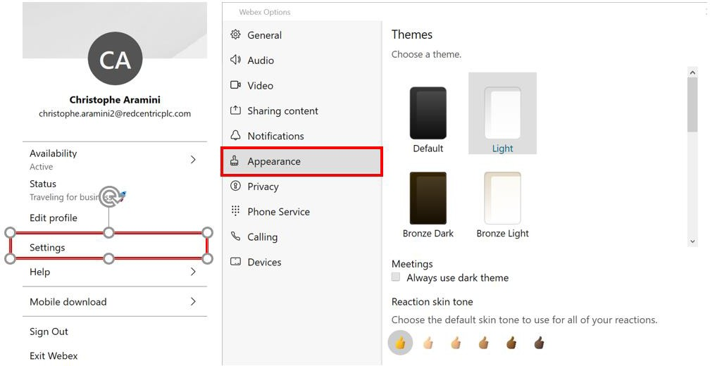

***Note:*** *Additional Theme options maybe released as part of ongoing service updates*

## The Webex App for Windows and Mac

The following sections provide an introduction of the capability provided within Redcentric’s Webex Collaborate service.

### Client Overview

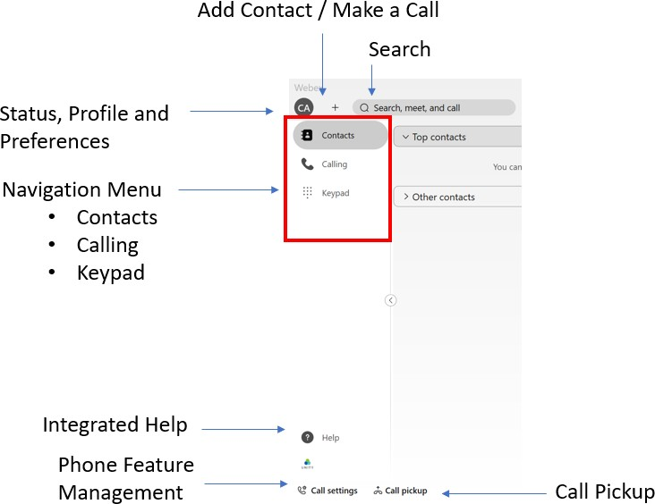

### Status, Profile and Preferences

This is your profile initials by default, but you can personalise this by adding display name and picture. Users can also set their status and availability, and this will be published to all users within the organisation.

### Changing User Profile Picture

Users can update their profile picture by clicking on their **Profile Icon > Edit Profile > Change Photo**

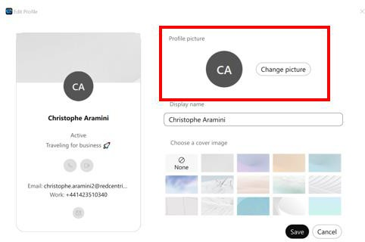

### Changing User Status

Users can update their status by clicking on their **Profile icon > Settings > Status** from here a user can update their status and add up to 75 letters worth of descriptive text.

### Changing Availability Status

Users can update their Availability status by accessing **Profile icon > Settings > Availability**

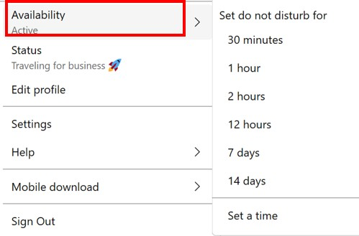

Setting the **DND** status will be reflected against the user’s profile icon/picture. This status will be presented out to all users within the organisation.

### Navigation Menu

In the Webex Softphone only version there are 3 panes available here.

### A picture containing text Description automatically generatedContacts

This allows you to view and search for contacts and view and contacts you have saved. You can create new contact groups and create new contacts as well as use existing Unity Contacts.

### A picture containing text Description automatically generatedCalling

This shows you a full call history. Missed calls show as a counter on the Icon as above, clicking on this will also show if you have any Voicemails if configured. You can select calls from your call history to call back

### A picture containing text Description automatically generatedKeypad

This shows the keypad to enable you enter a number to dial, simply type a number or extn or paste a number from a document, email or web page.

### A picture containing logo Description automatically generatedHelp

Webex application help can be accessed by clicking on the question mark icon at the bottom of the side bar. at the bottom of your sidebar.

### Add Contact/Make Call

A user can add a new contact to their contact list(s) in one of two ways.

Click the **+** next to the profile picture brings up the option to **Make a call** or **Add a contact**

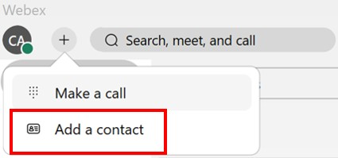

**Right click** on a number from the recent call list will open up a new contact card to complete.

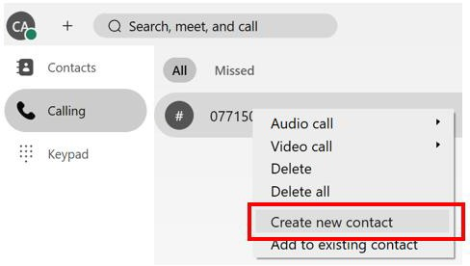

Both options will open a new contact card that can be completed with the new contacts information

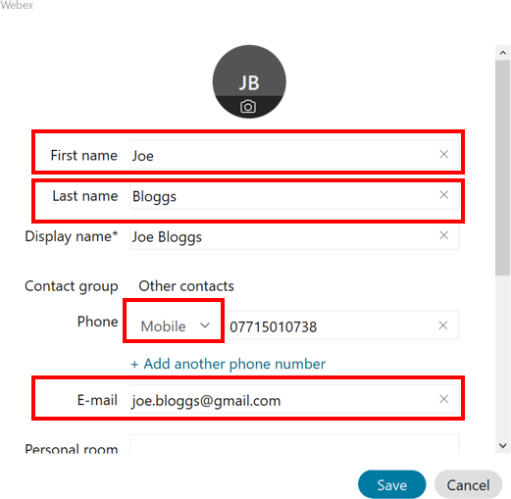

Once saved, the new contact will show up in **Other Contacts**

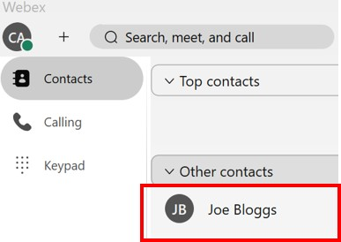

### Search

Users can search through their enterprise and saved contacts to find people they have contact with The search function will bring back search results from the core telephony service, stored local contacts and Outlook stored contacts.

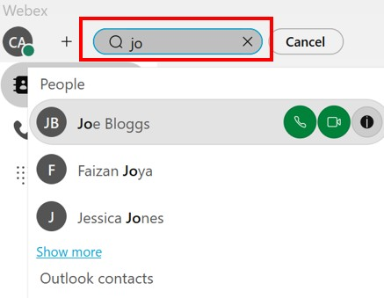

### Devices

Users can connect to associated handsets allowing users to initiate calls from the identified devices.

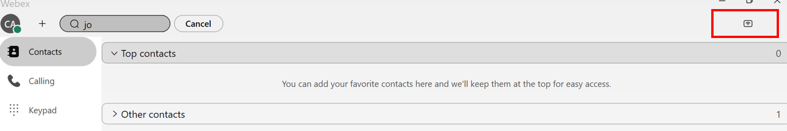

### Call Settings

The **Call Settings** menu item provides users with an option to configure allocated Unity calling / features. (e.g. Voicemail, Call Forward Settings).

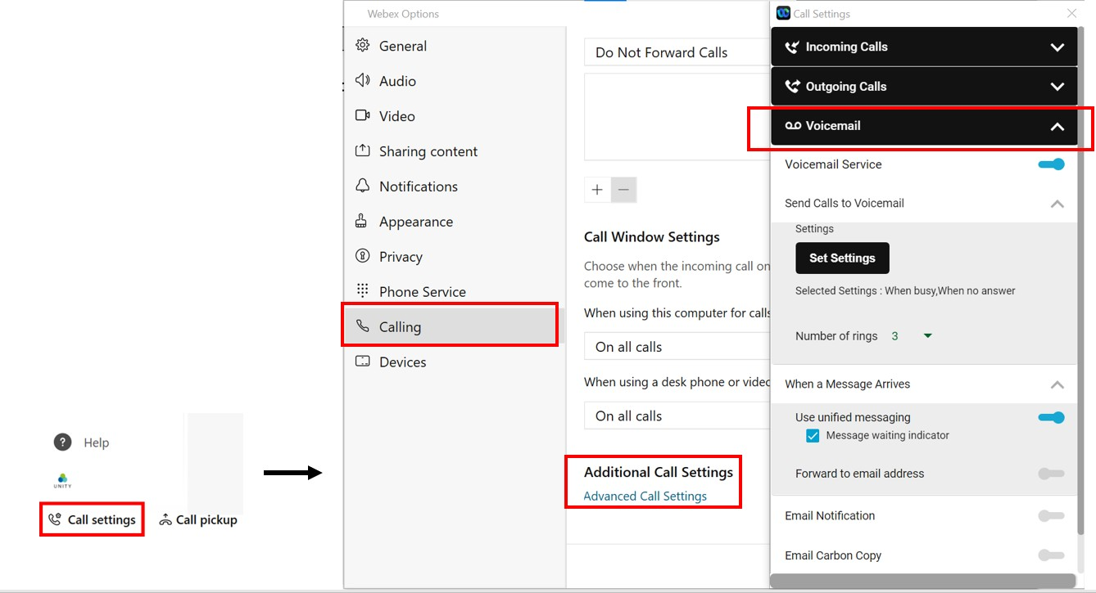

### Call Pickup

Use this option to select Call Pick up function if assigned it will also show the directed call pick up option allowing you to pick up a call ringing on a specific device.

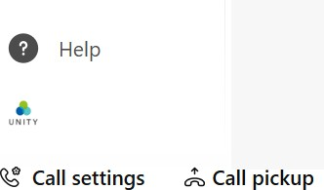

### Voicemail

Users will get a visual indication of calls missed and voicemails deposited.

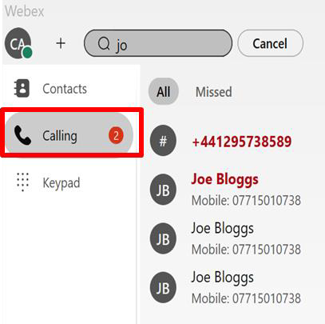

### Personalising Your Webex Collaborate Service

Users can personalise their own application environment. The following sections provide an overview of the options avaible to the end user of the service.

### Settings

View your Webex application settings click on your profile icon and the following menu will be displayed.

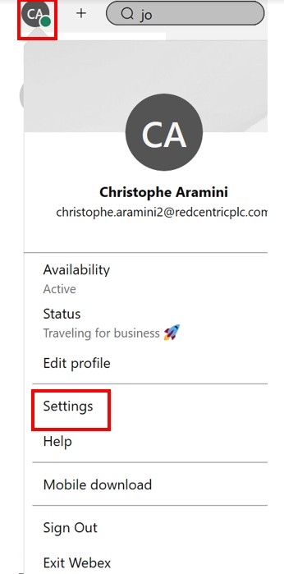

### Settings: General

Users can:

* Configure the Webex application to auto start when the computer starts.
* Connect their client to their Microsoft Outlook client
* Configure their default landing screen

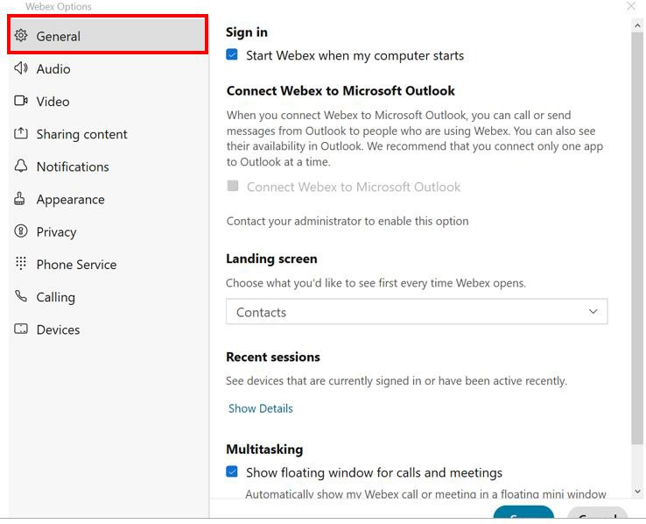

### Settings: Audio

Users can:

* Set ringer alerting
* Volume Levels
* Prioritise speaker alerts
* Set microphone preferences
* Manage noise cancellation
* 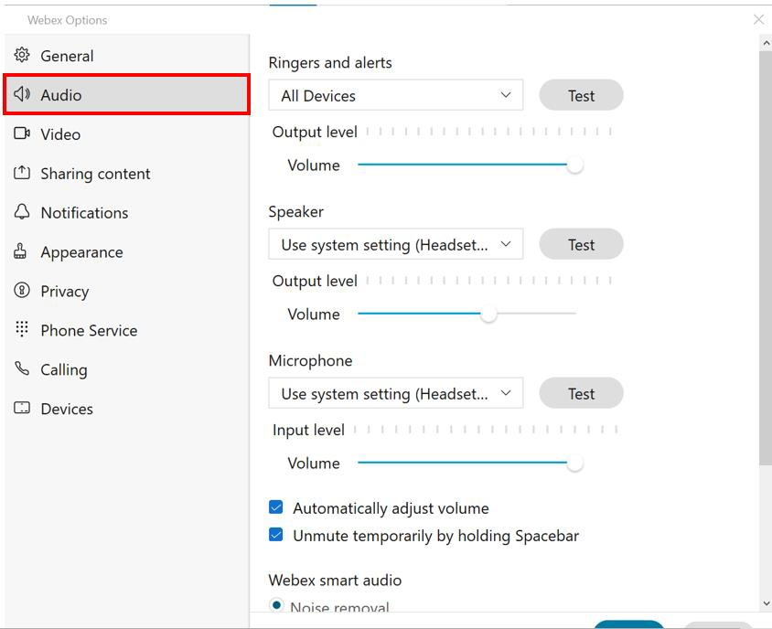

### Settings: Video

Users Can:

* Set Background
* Preview Camera Views
* Enable hardware acceleration
* Mirror Video
* Enable HD

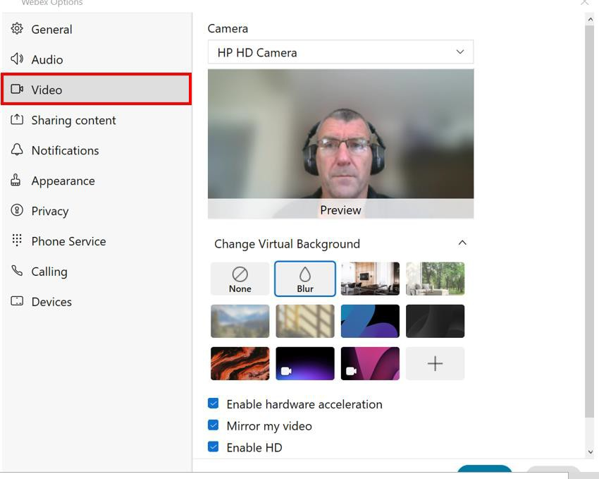

### Settings: Notifications

Users Can:

* Set meeting join preferences
* Set notification preferences when in meetings
* Set meeting join/exit notification preferences
* 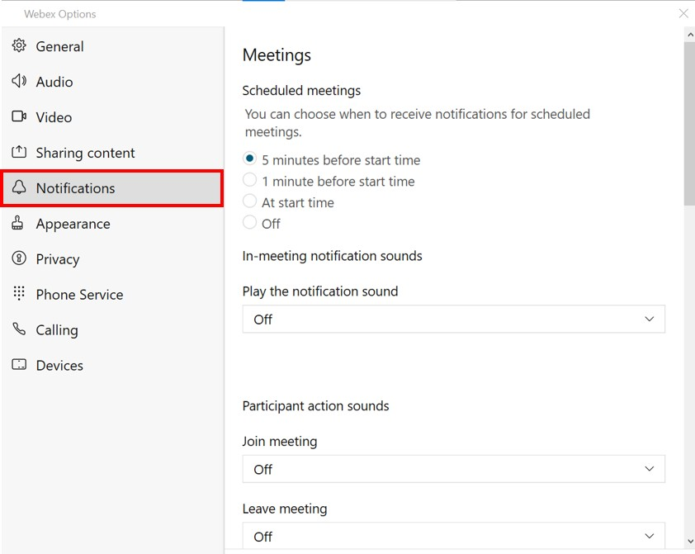

### Settings: Privacy

Users can:

* Control availability and general status
* Manage availability and status from other persons within the organisation

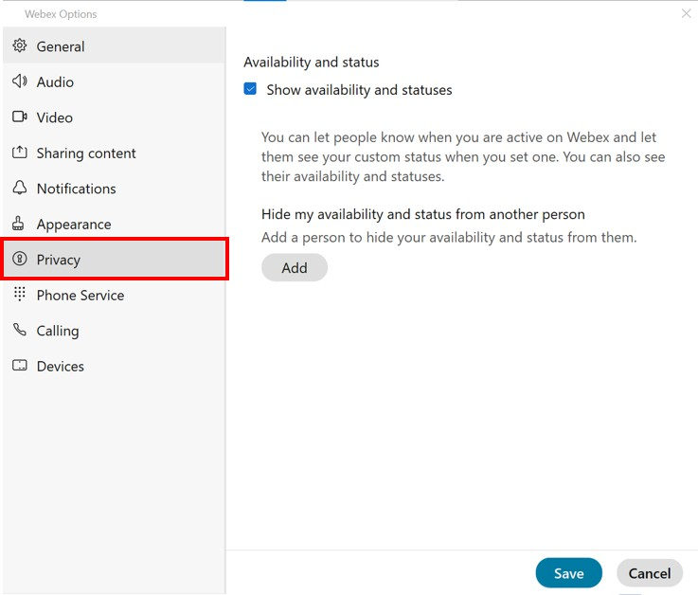

### Settings: Appearance

Users Can:

* Set their personal colour theme. Note: Requires application restart to pick up theme change
* Option to apply separate meeting theme
* Option to set reaction skin tones

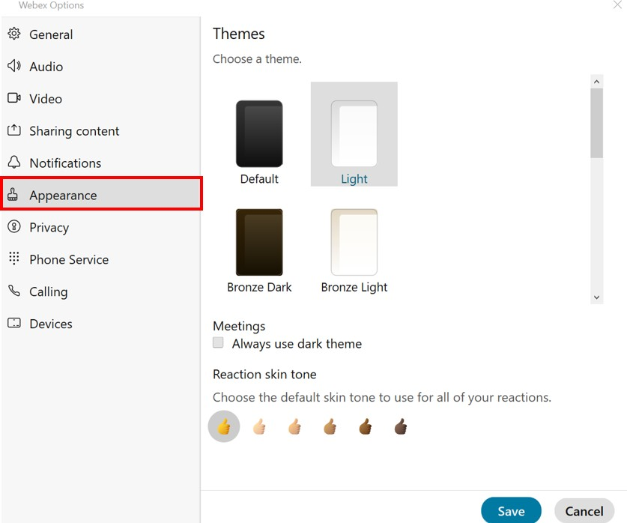

### Settings: Phone Service

User can:

* Check/confirm their phone service registration status

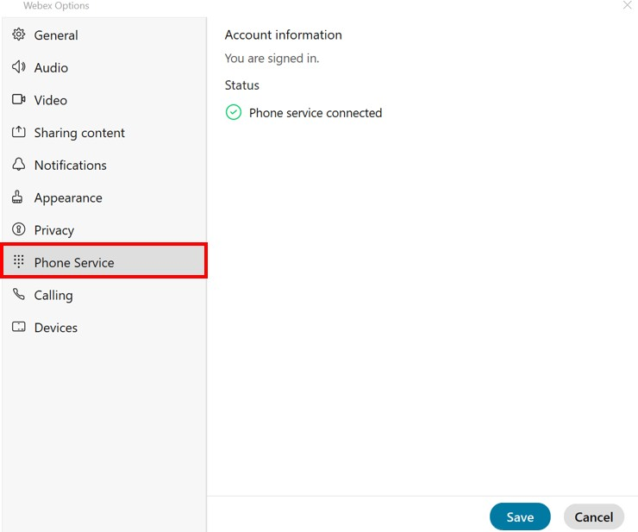

### Settings: Calling

Users Can:

* Set Incoming Call answering preferences
* Set call forward settings for Webex Only Calls
* Set preferences for positioning of the client when receiving incoming call
* Access to manage Unity phone services

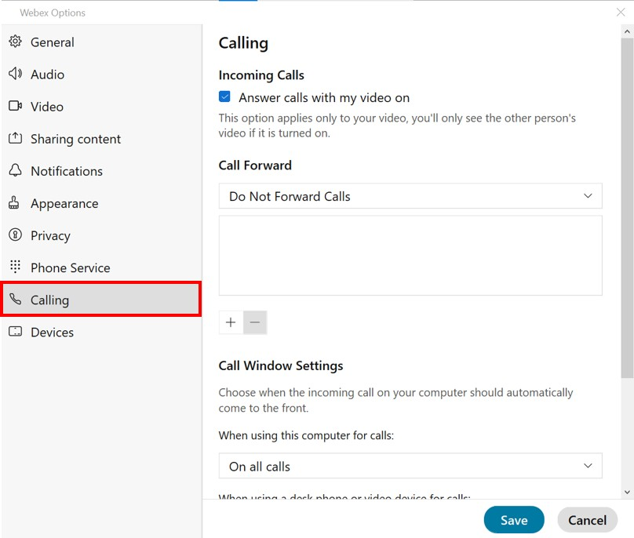

### Settings: Advanced Call Settings

Users Can:

Manage assigned Unity features.

* **Incoming Calls** includes, Do Not Disturb, Call Forwarding All/Busy/No Answer, Remote office, Call Waiting etc
* **Outgoing Calls** includes, Block Caller ID
* **Voicemail** includes Enable/Disable VM, No of Rings to No Answer and voicemail notification option settings
* **Call Control** includes Call Centre Membership, Sign in and Status changes

All the features displayed in within the Advanced Call Settings window are dependent on the services being active within your Unity subscription.

Please contact your system administrator if you think anything is not being displayed correctly.

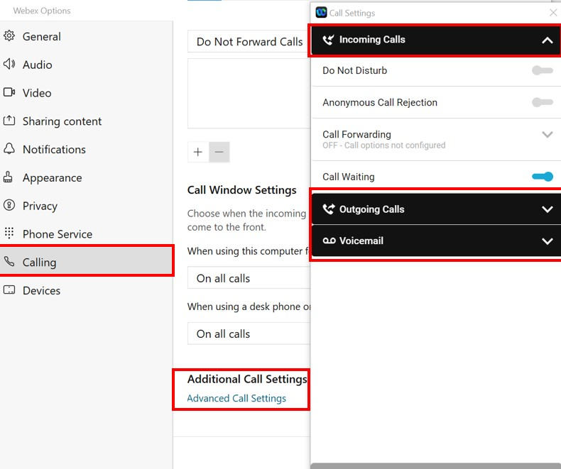

### Settings: Devices

Users Can:

* Utilise settings to manage device preferences

